

**Software Development Project Partial Documentation**

**AAPP006-4-2-SDP**

**Group Members:** Khor Zhe Sheng TP035053

Koa Choong Foo TP034743

Koh Huei Yee TP034714

Aaron Chan Weng Loong TP034921

**Intake Code:** UCDF1405ICT (SE)

**Lecturer:** Mr. Shum Yew Mun

**Hand out date:** 25th January 2016

**Hand in date:** 18th February 2016

**Table of content**

Acknowledgement 2

Introduction 3

Context diagram 4

Data flow diagram (DFD) 5

Workload matrix 6

Hierarchy chart 7

Screens design 8

Report design 21

Test plan 23

Limitations 41

Future Enhancements 41

Assumption 42

Other Requirements 42

References 43

Appendix 44

# Acknowledgement

We would like to express our earnest gratitude to our lecturer, Mr. Shum Yew Mun for his supervision and guidance throughout the execution of our project. Our work would not be possible without his continuous support. We are also extremely grateful to have one another as group members (KOH HUEI YEE, KOA CHOONG FOO, AARON CHAN WENG LOON & KHOR ZHE SHENG), contribution from each of us has only brought the project to its completion without a hitch.

Apart from that, Asia Pacific University of Technology & Inovation (APU) has played a huge role in this for providing us the necessary facilities and studying environment. Giving us the chance to experience and obtain the appropriate resources through the library to bring the project closer to its next step.

# Introduction

Our company has been the pioneer in providing customized software solution for various industries. The product our company has set out to create for the market is Hotel Management System (HMS) currently. HMS could be utilized by hotels, inns or any other lodging houses for managing rooms, facilities, reservations, check-ins, check-outs, billings, payments and other relevant transactions and services related to the hotel industry. HMS basic functionalities could be categorized into 3 kinds of management, Rooms and Facilities Management, Reservations Management and Front Desk Management.

Rooms and Facilities Management, would allow employees or users of the system to create and add new room if there is any. Rooms could be deleted from the system too, as well as updating and modifying room details. Same goes to creating and adding new facilities or services such as banquet halls, restaurants, gymnasium, spa, promotions and so forth. Options for updating, modifying and deleting facilities or services details should also be available. The search functionality for rooms and facilities is also present.

Reservations Management lets user or staff make reservations for groups or individuals. Updating, modifying and deleting reservations are also some of the basic functionalities which should be included. Booking fees or any other payments made will also be recorded. Searching for reservations made and generating reservations reports are included too.

On the other hand, Front Desk Management will usually handle individuals and groups check-ins and check-outs. Billings and payments made through cash and credit cards are both allowed. Similar to the features mentioned previously, searching for the details of each check-ins and check-outs, payments and related records should be available too. Lastly, daily collection reports could also be generated regularly.

# Context diagram



# Data flow diagram (DFD)



# Workload matrix

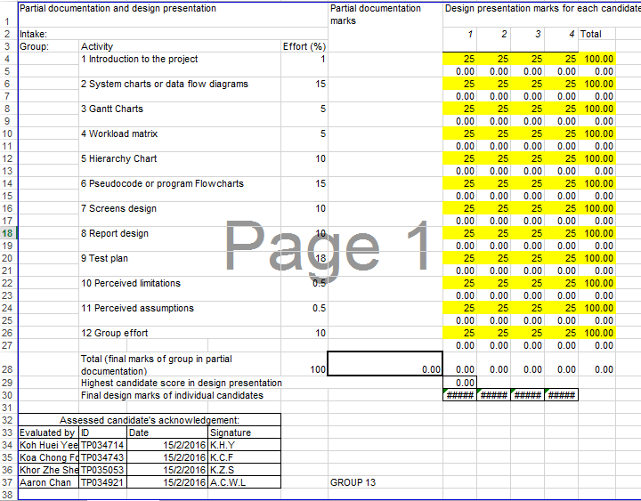

# Hierarchy chart



# Screens design

**Welcome.vb**

Welcome header

Hotel/Company Logo or Image

Welcome message label, register account only if there’s currently no account present in the system.

Register button

**FirstRegister.vb**

Register header

Account registration message label

Check Availability button

Username textbox

Username label

Password textbox

Password label

Select area(s) in-charge by the account

Radio button for Rooms & Facilities Management

Radio Button for Reservations Management

Radio button for Front Desk Management

Accept button

Reset Button

Cancel Button

**Login.vb**

Hotel/Company Logo or Image

Hotel System Management header

Username text box

Username Label

Password text box

Password Label

Exit button

Login button

**RFManagement.vb**

Rooms & Facilities Management header

Tab pages for rooms & facilities information

Add new room button

Add new facility/service button

Update facility/service button

Delete facility/service button

Update room details button

Delete room button

Search button

Search text box

Logout button

Menu button

**RFMAddDataEntry.vb**

Rooms & Facilities Management header

Room number text box

Room No.: label

Add room radio button

Combo box

Room type: label

Price text box

Price: label

Add facility/service radio button

Price: label

Facility/Service type: label

Facility/Service No.: label

Combo box

Facility/service number text box

Price text box

Cancel button

Reset button

Add button

**RFMUpdateDataEntry.vb**

Add button

Reset button

Cancel button

Facility/Service No.: label

Facility/Service type: label

Price: label

Combo box

Facility/service number text box

Price text box

Price text box

Room number text box

Combo box

Price: label

Room type: label

Room No.: label

Rooms & Facilities Management header

Update room radio button

Update facility/service radio button

**MenuForAdmin.vb**

Main Menu header

Reservation Management button

Rooms & Facilities Management button

Register an account button

Front Desk Management button

**AdminRegister.vb**

Account Registration header

Select account position label

Staff radio button

Admin radio button

Username text box

Password Label

Username Label

Check Availability button

Password text box

Select area(s) in-charge by the account

Radio button for Rooms & Facilities Management

Radio Button for Reservations Management

Radio button for Front Desk Management

Accept button

Cancel Button

Reset Button

**AddPaymentRM.vb**

Reservation Number Label

Reservation Management Payment header

Room number text box

Room Number: Label

Night(s) text box

Duration: Label

Combo box

Room Type: Label

Total amount paid: Label

Deposit paid text box

Memo/Extra Details: Label

Customer’s I/C number text box

Customer’s Name: label

Customer’s Phone Number: label

Customer’s Name text box

Customer’s Phone number text box

Company name: label

Company name text box

Number of Person(s) name: label

Number of Person(s) text box

Total Amount paid text box

Deposit paid: Label

Total Reservation(s) Price: Label

Extra/Additional Payment: Label

Price text box

Price text box

Memo/Extra Details text box

I/C Number: label

**RMAddFSDataEntry.vb**

OK button

Reset Button

Cancel Button

Reservation Number Label

Facility/Service Reservation Data Entry header

Facility/Service number text box

Facility/Service No.: Label

Combo box

Facility/Service Type: Label

Amount of person(s) text box

Number of Person(s): Label

Price text box

Booking Price: Label

Customer’s Name text box

Customer’s Name: Label

I/C Number: label

Company name: label

Company name text box

Number of Person(s) name: label

Number of Person(s) text box

Customer’s I/C number text box

Customer’s Contact Number text box

Customer’s Phone Number: Label

Duration: Label

Hour(s) text box

Reset Button

Add button

Cancel Button

**RMAddRoomDataEntry.vb**

Reservation Number Label

Room Reservation(s) Data Entry header

Room No.: Label

Room Type: Label

Number of Person(s): Label

Booking Price: Label

Facility/Service number text box

Amount of person(s) text box

Price text box

Combo box

Customer’s Name: label

Customer’s Phone Number: label

Customer’s Name text box

Customer’s Phone number text box

I/C Number: label

Company name: label

Company name text box

Number of Person(s) name: label

Number of Person(s) text box

Customer’s I/C number text box

Duration: Label

Night(s) text box

Cancel Button

Reset Button

Add button

**RMMenu.vb**

Reservation Management Data Entry header

New Room Reservation button

New Facility/Service button

**RMReport.vb**

Reservations Management Report header

Tab pages for reservation management information, day/week/month/year

OK button

**RMUpdateDataEntry.vb**

Reservation Management Data Entry header

Reservation Number Label

Date

Time

Update facility/service reservation check box

Facility/Service No.: label

Facility/Service type: label

Price: label

Combo box

Facility/service number text box

Price text box

Customer’s Name: label

Customer’s Phone Number: label

Customer’s Name text box

Customer’s Phone number text box

I/C Number: label

Customer’s I/C number text box

Company name: label

Company name text box

Number of Person(s) name: label

Number of Person(s) text box

Cancel button

Update button

Reset button

Deposit text box

Customer’s Name: label

Customer’s Phone Number: label

Customer’s Name text box

Customer’s Phone number text box

Deposit: label

I/C Number: label

Customer’s I/C number text box

Company name: label

Company name text box

Balance text box

Balance: label

Room Price text box

Room Price: label

Number of Person(s) name: label

Number of Person(s) text box

Update room reservation radio button

Room No.: label

Room type: label

Combo box

Room number text box

**FDMCheck_in.vb**

Date

Time

Reservation Number Label

Check-In header

New/Walk-in room reservation check box

Balance text box

Balance: label

Room Price: label

Room Price text box

Room No.: label

Room type: label

Deposit: label

Combo box

Deposit text box

Room number text box

Duration: label

Hour(s) text box

Customer’s Phone number text box

Customer’s Name text box

Customer’s Phone Number: label

Customer’s Name: label

Customer’s I/C number text box

I/C Number: label

Company name: label

Company name text box

Number of Person(s) name: label

Number of Person(s) text box

Check-in button

Cancel button

Reset button

Night(s) text box

Duration: label

Number of Person(s) name: label

Number of Person(s) text box

Customer’s Name text box

Customer’s Phone number text box

Customer’s Phone Number: label

Customer’s Name: label

Company name text box

Company name: label

Customer’s I/C number text box

I/C Number: label

Price text box

Facility/service number text box

Combo box

Price: label

Facility/Service type: label

Facility/Service No.: label

New/Walk-in facility/service reservation check box

**FDReport.vb**

Front Desk Management Report header

Tab pages for front desk management information, day/week/month/year

OK button

**FrontDeskManagement.vb**

Front Desk Management header

Tab pages for front desk management information

Check-in(s) button

Check-out(s) button

Menu button

Logout button

Search text box

Search button

Daily/Weekly/Monthly/Yearly Report button

Total invoice button

**InvoiceFDM.vb**

Front Desk Management Invoice header

Invoice Number

Reservation No.

Time

Date

Customer’s Name: label

Customer’s Phone Number: label

Customer’s Name text box

Customer’s Phone number text box

Number of Person(s) text box

Number of Person(s) name: label

Company name text box

Company name: label

Customer’s I/C number text box

I/C Number: label

Tab pages with information of total room(s)/facility & service price, and misc. items

Memo/Extra Details text box

Total amount paid: Label

Outstanding balance: Label

Deposit paid: Label

Extra/Additional Payment: Label

Deposit paid text box

Price text box

Outstanding balance text box

Total Amount paid text box

Memo/Extra Details: Label

Cancel Button

OK button

**Reservations_Management.vb**

Reservations Management header

Tab pages for reservation information

Extra payment(misc.) button

Reservation report button

Search button

Search text box

Logout button

Add new payment button

Delete reservation button

Menu button

Update reservation button

Add new reservation button

# Report design

Daily sales report

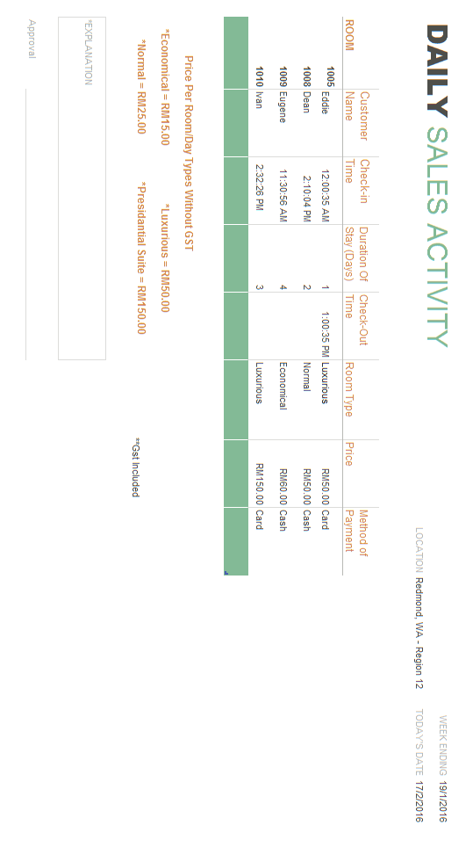

Monthly sales report

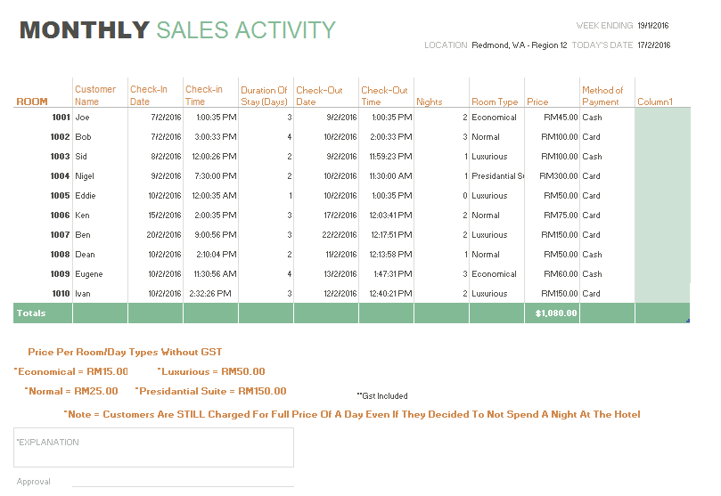

# Test plan

Welcome page

|  |  |  |
| --- | --- | --- |
| Test Case | Expected Result | Actual Result |
| Click on “Register” button | Go to First Register form. |  |
| Click on “Exit” | Close the system. |  |

Login

|  |  |  |
| --- | --- | --- |
| Test Case | Expected Result | Actual Result |
| Enter Correct Admin ID and Password and click “Login” | Pop out welcome message and go to Main Menu (Admin). |  |
| Enter Correct User ID and Password and click “Login” | Pop out welcome message and go to Home Page of the particular tasks. |  |
| Enter incorrect User/Admin ID or Password and click “Login” | Error message notifying incorrect username or password. |  |
| Click on “Exit” button | Close the program. |  |

Main Menu (Admin)

|  |  |  |
| --- | --- | --- |
| Test Case | Expected Result | Actual Result |
| Click on “Register an Account” | Go to Admin Register form. |  |
| Click on “Room and Facilities Management” | Go to Room & Facilities Management form. |  |
| Click on “Reservation Management” | Go to Reservation Management form. |  |
| Click on “Front Desk Management” | Go to Front Desk Management form. |  |
| Click on “Exit” button | Close the program. |  |
| Click on “Log out” | Go to Login form. |  |

First Register form

|  |  |  |
| --- | --- | --- |
| Test Case | Expected Result | Actual Result |
| Enter username/ID, password, select area(s) responsible and click on “Accept” | Pop out the confirmation message. If yes, pop out “Account is created successfully” message and Go to Main Menu (Admin). If no, remain the data in all field. |  |
| Enter username/ID as well as password and click on “Accept” | Pop out the error message that notify the user to full fill the register form. |  |
| Click on “Reset” | Empty all field. |  |
| Click on “Cancel” | Close First Register form and Go to Welcome page. |  |
| Click on “Exit” | Close the system. |  |

Room and Facilities management

|  |  |  |
| --- | --- | --- |
| Test Case | Expected Result | Actual Result |
| Click on “Add New Room(s)” | Go to Room and Facilities Management Data Entry- add form. |  |
| Click on “Add New Facility/Service” | Go to Room and Facilities Management Data Entry - add form. |  |
| Click on “Update Room(s) Details” | Go to Room and Facilities Management Data Entry - update form. |  |
| Click on “Update Facility/Service” | Go to Room and Facilities Management Data Entry - update form. |  |
| Select a room record on list and click on “Delete Room” | Pop out confirmation message. If yes, pop out “The room record is deleted successfully” message and the selected record is deleted from the list. If no, remain the selected room record. |  |
| Select a facility/service record on list and click on “Delete Facility/Service” | Pop out confirmation message. If yes, pop out “The facility/service record is deleted successfully” message. If no, remain the selected facility/service record. |  |
| Enter existed room id or facility/service id and click on “Search” | Pop out the details of that particular room or facility/service id in correct fields of search result tab. |  |
| Enter room id or facility/service id that does not exist and click on “Search” | Pop out error message notifying the user about the room or facility/service id that entered does not exist and clear the search text field. |  |
| Click on “Log Out” | Go to Login form. |  |
| Click on “Exit” | Close the system. |  |

Room and Facilities management Data Entry - Add

|  |  |  |
| --- | --- | --- |
| Test Case | Expected Result | Actual Result |
| Select add room, Enter existed room number, room type as well as price and click “Add” | Pop up error message notifying user the room number is existed and clear the room no. field. |  |
| Select add room, Enter room number that does not exist, room type as well as price and click “Add” | Pop up confirmation message. If confirm to add, pop out “The new room record is created successfully” message and ask the user whether to continue adding new room. If yes, clear the data in all field while if no, go to Room and Facilities management form. If not confirm to add, remain the data in all field. |  |
| Select add facility/service, Enter existed facility/service number, facility/service type as well as price and click “Add” | Pop up error message notifying user the facility/service number is existed and clear the facility/service no. field. |  |
| Select add facility/service, Enter facility/service number that does not exist, facility/service type as well as price and click “Add” | Pop up confirmation message. If confirm to add, pop out “The new facility/service record is created successfully” message and ask the user whether to continue adding new facility/service. If yes, clear the data in all field while if no, go to Room and Facilities management form. If not confirm to add, remain the data in all field. |  |
| Select add facility/service or room but did not fulfill the information required and click “Add” | Pop up error message notifying user to full fill the information required. |  |
| Click on “Reset” | Clear the data in all fields |  |
| Click on “Cancel” | Go to Room and Facilities management form. |  |
| Click on “Exit” | Close the system |  |

Room and Facilities management Data Entry - Edit

|  |  |  |
| --- | --- | --- |
| Test Case | Expected Result | Actual Result |
| Select update room, change room type as well as price and click “Update” | Pop up confirmation message. If yes, pop out “The selected room record is updated successfully” message. If no, remain the data in all field. |  |
| Select update facility/service, change facility/service type as well as price and click “Update” | Pop up confirmation message. If yes, pop out “The selected facility/Service record is updated successfully” message and Go to Room and Facilities management form. If no, remain the data in all field. |  |
| Click on “Reset” | Clear the data in all fields. |  |
| Click on “Cancel” | Go to Room and Facilities management form. |  |
| Click on “Exit” | Close the system. |  |

Account Registration form

|  |  |  |
| --- | --- | --- |
| Test Case | Expected Result | Actual Result |
| Choose admin/staff, enter existing username/ID and click on “Check Availability” | Pop out error message and clear the username/ID field. |  |
| Choose admin/staff, enter username/ID that does not exist and click on “Check Availability” | Pop out the available message and remain the username/ID field. |  |
| Choose admin/staff, enter available username/ID, password, select area(s) responsible and click on “Accept” | Pop out the confirmation message. If yes, pop out “Account is created successfully” message and Go to Main Menu (Admin). If no, remain the data in all field. |  |
| Choose admin/staff, enter available username/ID as well as password and click on “Accept” | Pop out the error message that notify the user to full fill the register form. |  |
| Enter available username/ID, password as well as select area(s) responsible only and click on “Accept” | Pop out the error message that notify the user to full fill the register form. |  |
| Click on “Reset” | Empty all field. |  |
| Click on “Cancel” | Close Account Registration form and Go to Main Menu (Admin). |  |
| Click on “Exit” | Close the system. |  |

Front Desk Management

|  |  |  |
| --- | --- | --- |
| Test Case | Expected Result | Actual Result |
| Select a record from list and click on “Total Invoice” | Go to Front Desk Management Invoice form (auto capture the particular customer’s details from database). |  |
| Click on “Daily/ Weekly/ Monthly/ Yearly Report” | Go to Daily/ Weekly/ Monthly/ Yearly report form. |  |
| Click on “Check-In (s)” | Pop out error message notifying user to select a reservation record. |  |
| Select on a record and Click on “Check-In (s)” | Go to Check-in form (auto capture the details of selected record as well as display in check-in form). |  |
| Click on “Check-Out(s)” | Pop out error message notifying user to select one of the record from list. |  |
| Select on a record and Click on “Check-Out (s)” | Pop out the confirmation message. If yes, auto capture the system date and time and added into the columns named check-out date and time of the selected record row. If no, no changes to the record. |  |
| Enter existed reservation id and click on “Search” | Show the details of that particular reservation id in correct fields of search result tab. |  |
| Enter reservation id that does not existed and click on “Search” | Pop out error message notifying the user about the reservation id that entered does not exist. |  |
| Click on “Menu” | Go to Main Menu (Admin). |  |
| Click on “Log Out” | Go to Login form. |  |
| Click on “Exit” | Close the system. |  |

Front Desk Management - Check In

|  |  |  |
| --- | --- | --- |
| Test Case | Expected Result | Actual Result |
| Select New/Walk in room reservation, enter room number, select room type, enter deposit, customer’s name, customer’s telephone number, identification number, customer’s address, company name (company trip), date and time as well as number of person(s) and click on “Check-In” | Pop up a confirmation message. If yes, pop out “You are check-in successfully.” message and go to Front Desk Management form. If no, remain the data in all fields. |  |
| Select New/Walk in facility/service reservation, enter facility/service number, select facility/service type, enter price, customer’s name, customer’s telephone number, identification number, company name (company trip), date and time as well as number of person(s) and click on “Check-In” | Pop up a confirmation message. If yes, pop out “You are check-in successfully.” message and go to Front Desk Management form. If no, remain the data in all fields. |  |
| Enter few text fields but did not full fill the form and click “Check-In” | Pop up error message notifying user to full fill the form. |  |
| Click on “Reset” | Clear all data in the field. |  |
| Click on “Cancel” | Go to Front Desk Management. |  |
| Click on “Exit” | Close the system. |  |

Front Desk Management Invoice

|  |  |  |
| --- | --- | --- |
| Test Case | Expected Result | Actual Result |
| Enter room/facility/service price(s), extra charges items, extra payment as well as total amount paid (auto capture customer’s name, customer’s telephone number, identification number, company name(company trip), number of persons, deposit paid and outstanding balance from database) and click on “OK” | Pop out the confirmation message. If yes, pop out “The invoice is created successfully.” message and go to Front Desk Management form. If no, remain the data in all fields. |  |
| Enter all the details required except total amount paid and click on “OK” | Pop out the error message that notifying the user to fill in the amount paid. |  |
| Click on “Cancel” | Go to Front Desk Management. |  |
| Click on “Exit” | Close the system. |  |

Front Desk Management Report

|  |  |  |
| --- | --- | --- |
| Test Case | Expected Result | Actual Result |
| Click on “Daily” | Show daily report |  |
| Click on “Weekly” | Show weekly report |  |
| Click on “Monthly” | Show monthly report |  |
| Click on “Yearly” | Show yearly report |  |
| Click on “OK” | Go to Front Desk Management form. |  |
| Click on “Exit” | Close the system. |  |

Reservation Management

|  |  |  |
| --- | --- | --- |
| Test Case | Expected Result | Actual Result |
| Click on “Add New Reservation(s)” | Go to Reservation Management – Reservation Menu form. |  |
| Select a reservation record from list and click on “Update Reservation(s)” | Go to Reservation Management – Update form (auto capture the details of selected reservation record and display in update form). |  |
| Select a reservation record from list and click on “Delete Reservation” | Pop out confirmation message. If yes, pop out “The selected reservation record is deleted successfully” message and the selected record is deleted from the list. If no, remain the selected reservation record. |  |
| Select a reservation record from list and click on “Add New Payment” | Go to Reservation Management Invoice form and auto capture the details of selected reservation record. |  |
| Select a reservation record from list and click on “Extra Payment (MISC)” | Go to Reservation Management Invoice form and auto capture the details of selected reservation record. |  |
| Click on “Reservation Report” | Go to Reservation Management Report form. |  |
| Enter existed reservation id and click on “Search” | Pop out the details of that particular reservation id in correct fields of search result tab. |  |
| Enter reservation id that does not exist and click on “Search” | Pop out error message notifying the user about the reservation id that entered does not exist and clear the search text field. |  |
| Click on “Log Out” | Go to Login form |  |
| Click on “Exit” | Close the system |  |

Reservation Management - Reservation Menu

|  |  |  |
| --- | --- | --- |
| Test Case | Expected Result | Actual Result |
| Click on “New Room Reservation” | Go to Reservation Management Data Entry - Add new room reservation. |  |
| Click on “New Facility/Service Reservation” | Go to Reservation Management Data Entry - Add new facility/service reservation. |  |
| Click on “Exit” | Close the system |  |

Reservation Management Payment

|  |  |  |
| --- | --- | --- |
| Test Case | Expected Result | Actual Result |
| Enter deposit paid, extra charges items, extra payment as well as extra details (auto capture customer’s name, customer’s telephone number, identification number, company name (company trip), number of person(s), room/facility number, room/facility type and duration from database) and click on “OK” | Pop out the confirmation message. If yes, pop out “The payment is recorded successfully.” message and go to Front Desk Management form. If no, remain the data in all fields. |  |
| Enter all the details required except deposit paid and click on “OK” | Pop out the error message that notifying the user to fill in the deposit paid. |  |
| Click on “Reset” | Clear the data in all fields. |  |
| Click on “Cancel” | Go to Reservation Management form. |  |
| Click on “Exit” | Close the system |  |

Reservation Management Data Entry - Add new room reservation

|  |  |  |
| --- | --- | --- |
| Test Case | Expected Result | Actual Result |
| Enter unavailable room number, select room type, enter number of person(s), booking price(deposit), customer’s name, customer’s phone number, identification number, company name(company trip) as well as duration and click “Add” | Pop up error message notifying user that room is unavailable for reservation in that time frame and clear the room no. field. |  |
| Enter available room number, select room type enter number of person(s), booking price, customer’s name, customer’s phone number, identification number, company name(company trip) as well as duration and click “Add” | Pop up confirmation message. If confirm to add, pop out “The new reservation record is created successfully” message and ask the user whether to continue adding new reservation. If yes, go to reservation menu while if no, go to Reservation management form. If not confirm to add, remain the data in all field. |  |
| Enter few text fields but did not full fill the form and click “Add” | Pop up error message notifying user to full fill the form. |  |
| Click on “Reset” | Clear the data in all fields |  |
| Click on “Cancel” | Go to Reservation management form. |  |
| Click on “Exit” | Close the system |  |

Reservation Management Data Entry - Add new facility/service reservation

|  |  |  |
| --- | --- | --- |
| Test Case | Expected Result | Actual Result |
| Enter unavailable facility/service number, select facility/service type, enter number of person(s), booking price, customer’s name, customer’s phone number, identification number, company name(company trip) as well as duration and click “Add” | Pop up error message notifying user that facility/service is unavailable for reservation in that particular time frame and and clear the facility/service no. field. |  |
| Enter available facility/service number, select facility/service type enter number of person(s), booking price, customer’s name, customer’s phone number, identification number, company name(company trip) as well as duration and click “Add” | Pop up confirmation message. If confirm to add, pop out “The new reservation record is created successfully” message and ask the user whether to continue adding new reservation. If yes, go to reservation menu while if no, go to Reservation management form. If not confirm to add, remain the data in all field. |  |
| Enter few text fields but did not full fill the form and click “Add” | Pop up error message notifying user to full fill the form. |  |
| Click on “Reset” | Clear the data in all fields |  |
| Click on “Cancel” | Go to Reservation management form. |  |
| Click on “Exit” | Close the system |  |

Reservation Management Report

|  |  |  |
| --- | --- | --- |
| Test Case | Expected Result | Actual Result |
| Click on “Daily” | Show daily report |  |
| Click on “Weekly” | Show weekly report |  |
| Click on “Monthly” | Show monthly report |  |
| Click on “Yearly” | Show yearly report |  |
| Click on “OK” | Go to Reservation Management form. |  |
| Click on “Exit” | Close the system |  |

Reservation Management - Update reservation record

|  |  |  |
| --- | --- | --- |
| Test Case | Expected Result | Actual Result |
| Select update room reservation, change room type/ number of person(s)/ booking price/ customer’s name/ customer’s telephone number/ identification number/ company name(company trip)/ deposit/ room price and click “Update” | Pop up confirmation message. If yes, pop out “The selected room reservation record is updated successfully” message and go to Reservation management form.. If no, remain the data in all field. |  |
| Select update facility/service reservation, change facility/service type/ number of person(s)/ booking price/ customer’s name/ customer’s telephone number/ identification number/ company name(company trip)/ deposit/ room price and click “Update” | Pop up confirmation message. If yes, pop out “The selected facility/Service reservation record is updated successfully” message and go to Reservation management form. If no, remain the data in all field. |  |
| Click on “Reset” | Clear the data in all fields. |  |
| Click on “Cancel” | Go to Reservation management form. |  |
| Click on “Exit” | Close the system |  |

# Limitations

-Smaller businesses such as motels and apartments might find certain features included inside the system redundant and overly complicated due to the features which covered also external facilities which they might not have or able to provide properly (i.e.: gym, swimming pool, tennis court, etc.)

-Lack of online functionality thus may affect the user experience with the user.

-Rooms can only be added one at a time when inquiring on room availability as well as during reservations (not in a bulk even if the customer requests for multiple rooms with a maximum of only 2 rooms),

- The system is likely to only focus on the features covered within the system, thus any future enhancements desired by the user of the system may not be able to be made into the system.

# Future enhancements

-Additional methods of communication i.e.: Automated email with carbon copy function should the staff requires a notification to other such as reports, resignation, notices, etc.

-Actual linkage towards the credit card system, perhaps in the future our system will be in partnership with credit card and debit card companies to provide further means of protection and convenience for the customer.

-Conversion into a hybrid: being capable of not only local storage but also a form of web system whereby staff can access the system online and store information on web servers and reduce the need for any installation of other applications to run the system.

# Assumption

-Needless to say, any related staff should be familiar with the computer system or at least be provided with the minimal explanation on how the system functions.

-Any form of record and information will and only be made and inserted inside the database of the system by the staff alone.

-Incomplete registration of customer details will not allow the user to proceed on to storing the information.

# Other Requirements

1. For security purposes, you should have a password protected log-in page to verify the user type
2. You should include appropriate validations and error handling within your application
3. You may define other business rules or constraints after discussing them with your lecturer, tutor or supervisor.
4. More credit maybe given for internet or mobile based solution.

# References

Pabs, J., 2008. *Sourcecodester.* [Online]   
Available at: http://www.sourcecodester.com/blog/free-hotel-management-posting-charges.html

# Appendix